

# June 4, 2013

To: Kevin Berken, Wayne Zaunbrecher, Christian Richard, Kenneth Fairchild, Ronald Habetz, Ronnie “Blue” Zaunbrecher, Jimmy Hoppe, Robert Thevis, Jeff Durand, Dr. Mike Strain, Nicole Broussard, Scott Privat, and Carrie Castille.

Dear Board Members and Others:

I would like to call a meeting of the Louisiana Rice Promotion Board for Wednesday, June 26, 2013, in the LSU Rice Research Station Administration Building located at 1373 Caffey Road in Crowley. The meeting will be held at 1:00 p.m. immediately following the Rice Field Day program and luncheon.

We have several very important items of business to address including election of officers, renewing contracts, consideration of funding requests, and development of the 2012-13 budget.

Enclosed are:

* Meeting Agenda
* Draft minutes of the November 26, 2012 meeting
* Minutes of the October 29, 2012 meeting
* Report on in-state promotion projects, which includes proposed 2013-14 funding levels.
* Various funding request

Note: Additional information may be provided for your review prior to the meeting.

Please review these documents and be prepared to accept or amend them as needed.

Also enclosed is the current board roster. Please review your contact information on the roster and alert Julie Richard if there are any changes.

This is our most important meeting of the year. Please make every effort to attend.

Sincerely,

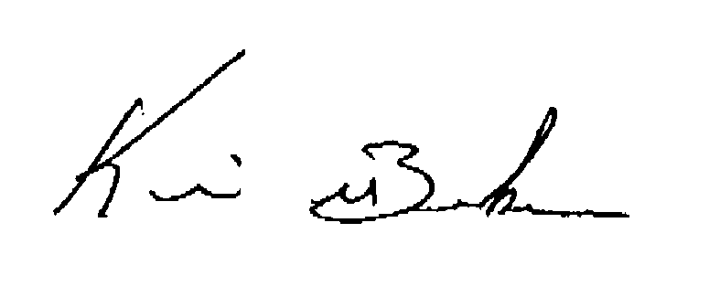

# Chairman